**Anit Mangal**

**21CS10005**

**DBMS Laboratory Assignment-2 Report**

**Commands Used:**

CREATE TABLE for creating various relations in the database, specifying attributes of each field along with PRIMARY KEY or FOREIGN KEY to maintain integrity.

INSERT INTO (TABLE) VALUES to insert records into relations.

SELECT to query according to need taking help from WHERE, JOIN clauses and COUNT function along with DISTINCT, LIMIT, GROUP BY and ORDER BY.

**Records Inserted:**

Schema:

STUDENT

Name VARCHAR

Roll CHAR PRIMARY KEY

Dept VARCHAR

RID INT FOREIGN KEY(ROLE.RID)

ROLE

RID INT PRIMARY KEY

Rname VARCHAR

Description VARCHAR

EVENT

EID INT PRIMARY KEY

EName VARCHAR

Date Date

Type VARCHAR

VOLUNTEER

Roll CHAR PRIMARY KEY

Dept VARCHAR

PARTICIPANT

PID INT PRIMARY KEY

Name VARCHAR

College_Name VARCHAR

College_Loc TEXT

MANAGE

Roll CHAR

EID INT FOREIGN KEY(EVENT.EID)

EVENT_PART

EID INT FOREIGN KEY(EVENT.EID)

PID INT FOREIGN KEY(PARTICIPANT.PID)

EVENT_VOL

EID INT FOREIGN KEY(EVENT.EID)

Roll CHAR FOREIGN KEY(VOLUNTEER.Roll)

**ROLE**

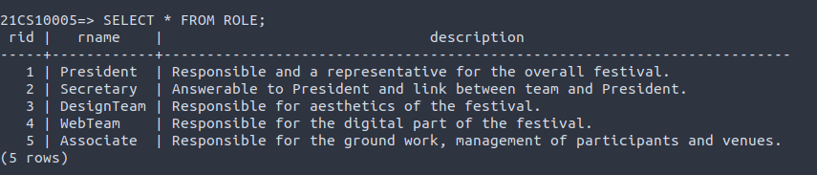

**STUDENT**

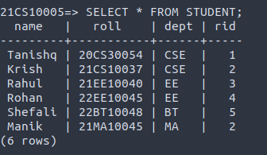

**EVENT**

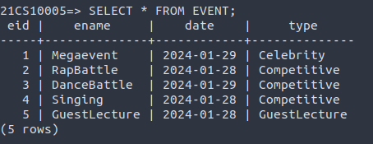

**VOLUNTEER**

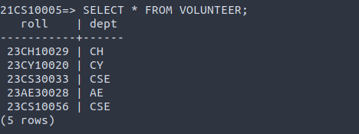

**PARTICIPANT**

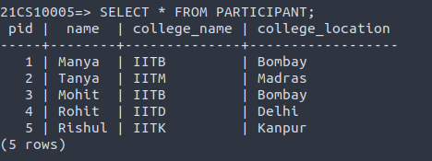

**MANAGE**

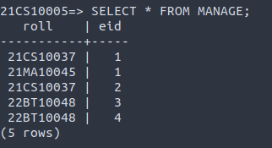

**EVENT_PART**

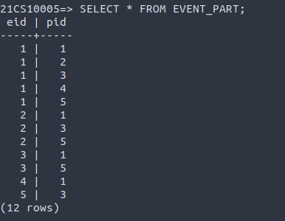

**EVENT_VOL**

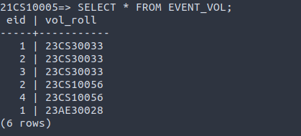

**Query Outputs:**

**Q1**

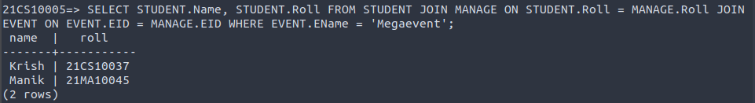**Q2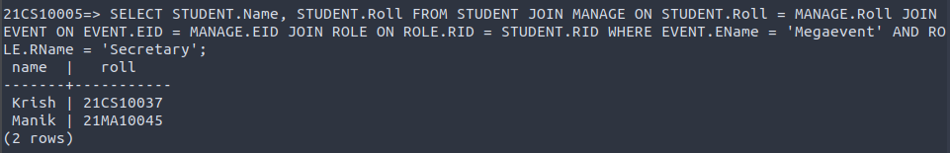Q3**

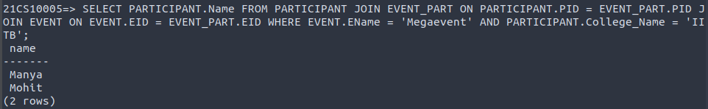**Q4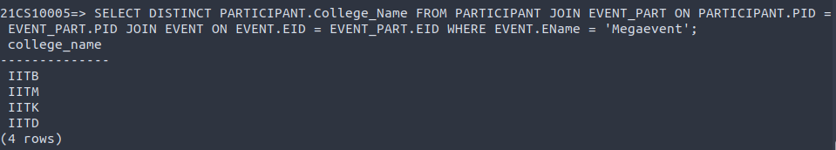Q5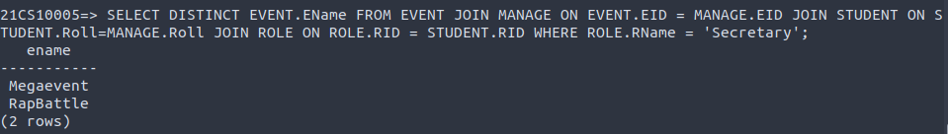Q6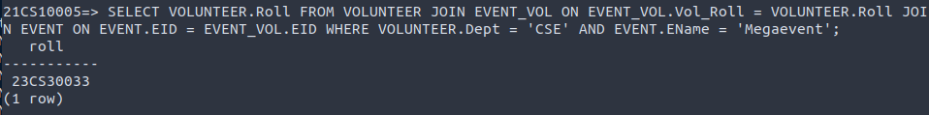Q7**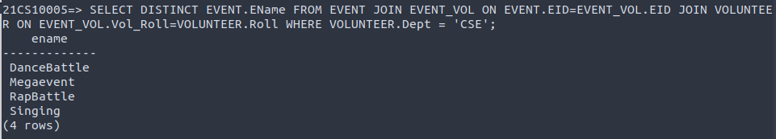

**Q8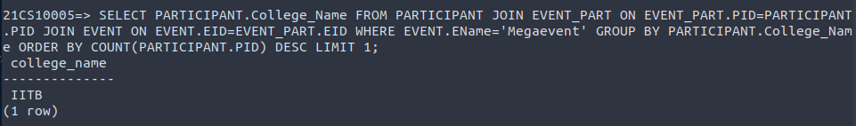Q9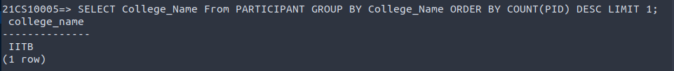Q10**